
Willington Primary School
Tic Tac Toe Half-Termly Learning Log
Year 5 – Spring 2
  Art  Create a drawing, painting or collage of a war scene. Look up other artists inspired by war.   | History  Research the work of Thomas Barnardo – present your information as a fact file, a biography or even as a news report! | Canal Art  Visit the canal (with an adult) and have a look at some of the canal art – have a go at your own designs.  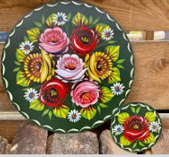
Easter Craft  Complete an Easter craft activity and photograph for your log – a painted egg, an Easter bonnet, a pop -up picture.   | Zones of Regulation  Show strategies and techniques that children could use to manage emotions. You can choose to represent this in any way you wish.  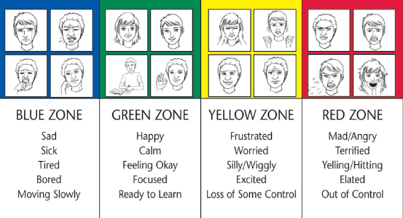 | Maths  Play TT Rockstars 3 times per week for a minimum of 5 minutes each time.  
  Geography  Research the Suez Canal and find out why it is important for trade and transportation.  What happened in March 2021 and what impact did this have? | French  Create a family tree showing when your family members were born using the French date e.g. le sept mai (7th of May). You may wish to include photos / drawings of your family members. | Spelling  Go on SpellingShed 3 times per week for a minimum of 5 minutes each time.
Complete at least 3 challenges so that you make a vertical, horizontal or diagonal line. You must include the middle square. Colour in each square as you complete that activity. To be complete no later than Tuesday 22nd April when we will celebrate and share all your projects.
The winning learning log will be awarded the 'Learning Log Trophy'.

