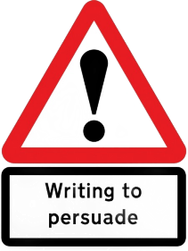
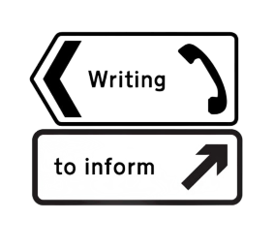
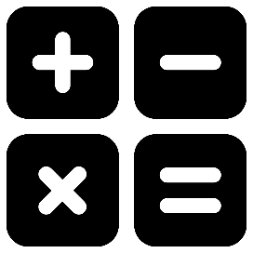







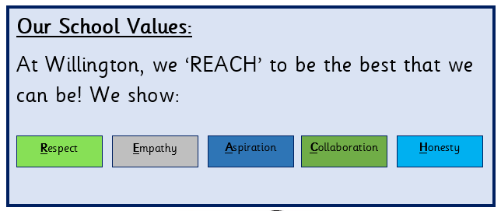







Story Time Spine
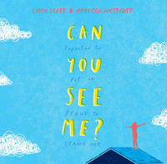
by Libby Scott and Rebecca Westcott
Proctected Characteristic - Disability

Protected Characteristics:
Age & Gender-
Spelling
Words ending in the suffixes:
-ant, -ance, -ancy, -ent, -ency, -able, -able, -ably & -ibly
Maths
Daily fluency (Fluent in 5), weekly TT Rockstars test and revisiting of topics (Flashback 4)
Our Class Texts
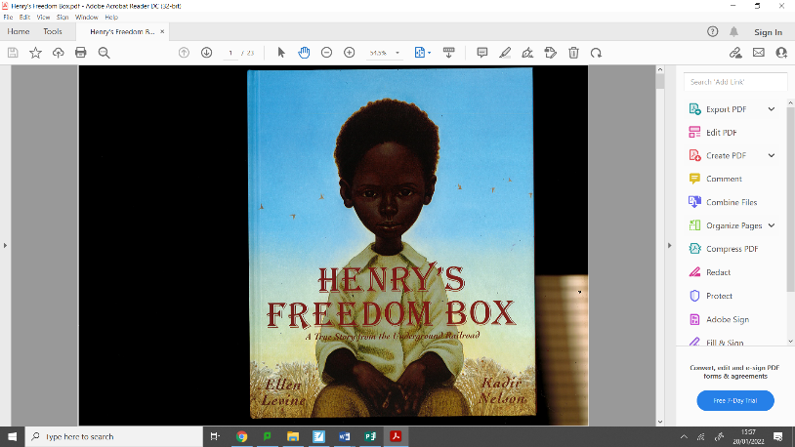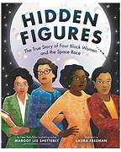
Henry’s Freedom Box by Ellen Lavine and Hidden Figures by Margot Lee Shetterly

Maths

Fractions and long multiplication
The Outstanding Otters
Year 5 Curriculum – Autumn 2
Writing (2 pieces)

Purpose: Writing to persuade
Persuasive letter from Henry Brown

Purpose: Writing to inform
A biography about one of the women from Hidden Figures

Where Pupils Succeed
Design and Technology
Food
Topic: Pasta Sauce

History
Topic: Ancient Greece

Computing
Digital Literacy: Digital Literacy: Online relationships & online reputation

Topic: Quizzing
Music
Topic: Classroom Jazz

Geography
Topic: Biomes

Science
Topic: Forces
Things you can do at home:
RE
Enquiry Question: what matters most to Christians & Humanists?
Religions and world views: Christians & non-religious

French
Topic: Pets

PE
Swimming & Gymnastics

PSHE
Topic: Difference and Diversity

