









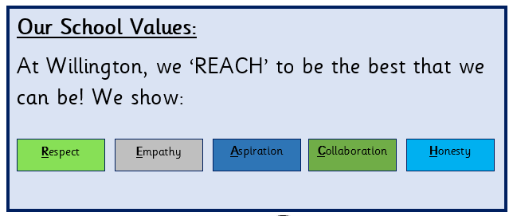









Writing (2 pieces)
Purpose: Writing to discuss
A speech about climate change
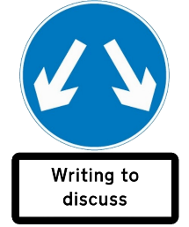
Purpose: Writing to entertain
A narrative poem inspired by The Last Bear.
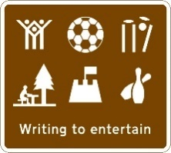

Story Time Spine
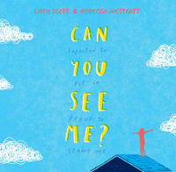
by Libby Scott and Rebecca Westcott
Protected Characteristic - Disability

Maths
Daily fluency (Fluent in 5), revisiting of topics (Flashback 4) and weekly TT Rockstars quiz.
Our Class Text
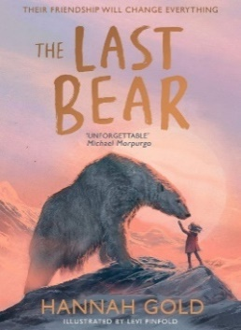
The Last Bear
by Hannah Gold
Maths
Short division, multiplying fractions, decimals
Spelling
Adverbs of time, silent letters, words with ‘ie’ after ‘c’
The Outstanding Otters
Year 5 Curriculum – Spring 1
Where Pupils Succeed
Geography
Topic: Biomes & Climate Zones

Art
Skill: drawing
Topic: Amazed by Architecture
History
Topic: The Victorian Era

Computing
Digital Literacy: Online Bullying

Topic: Databases & Game Creator
Music
Topic: Make you feel my love

PSHE
Topic: Exploring Emotions

Science
Topic: Living Things & their Habitats
Things you can do at home:
RE
Enquiry Question: Why is the Torah so important for Jewish people?
Religions and world views: Judaism

French
Topic: Date

PE
Dance and Dodgeball

