
Transition Booklet
for The Happy Hedgehogs
My new school is
Willington Primary School
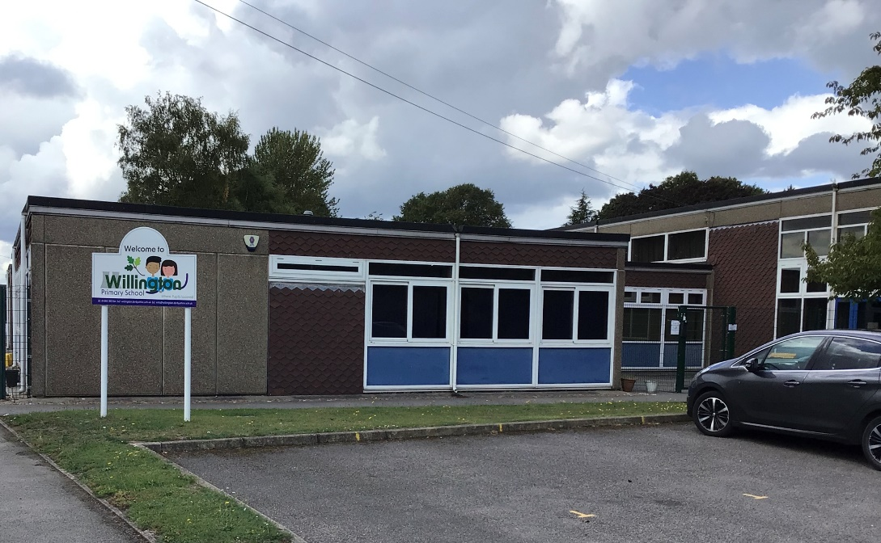
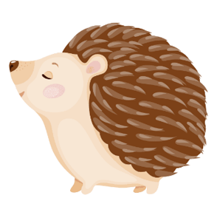

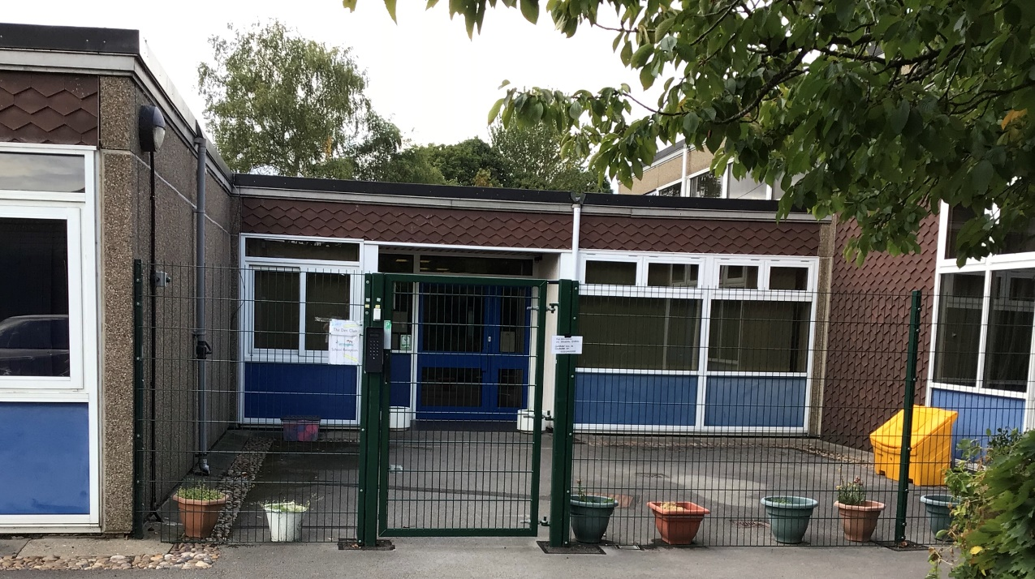

This is the front of the school, where I will meet my teacher during the first few days of school.
This is my teacher
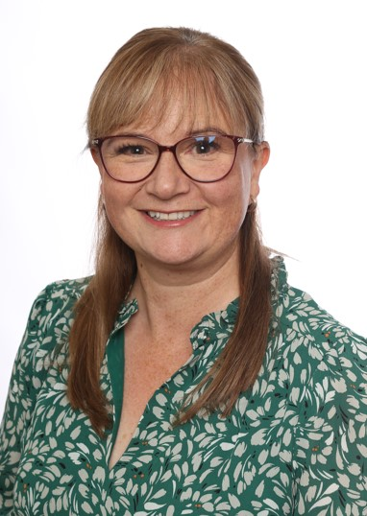
Mrs Miller



This is Mrs Power who will be working with The Happy Hedgehogs.

While at school, you may see
Mrs Sanderson and Mrs Cartwright.
They work in the office and
help us during lunch time.
​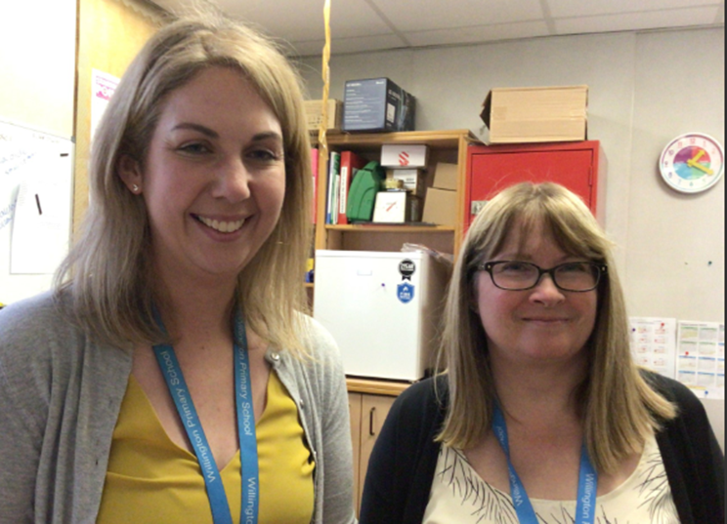
The Happy Hedgehog Classroom.
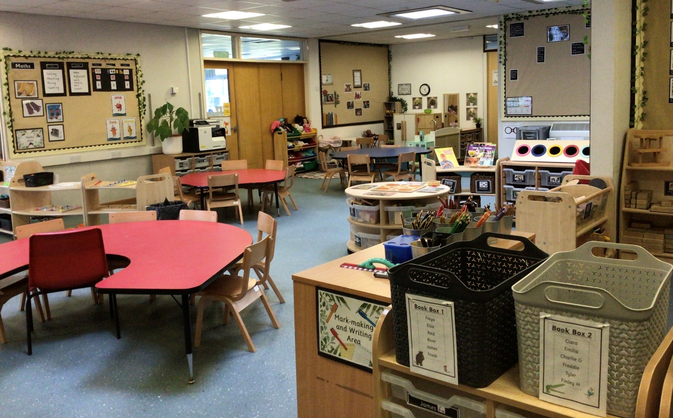

This is the outdoor area for the Happy Hedgehogs.

This is the other side of our classroom with a maths area, art/craft area and tables for learning.
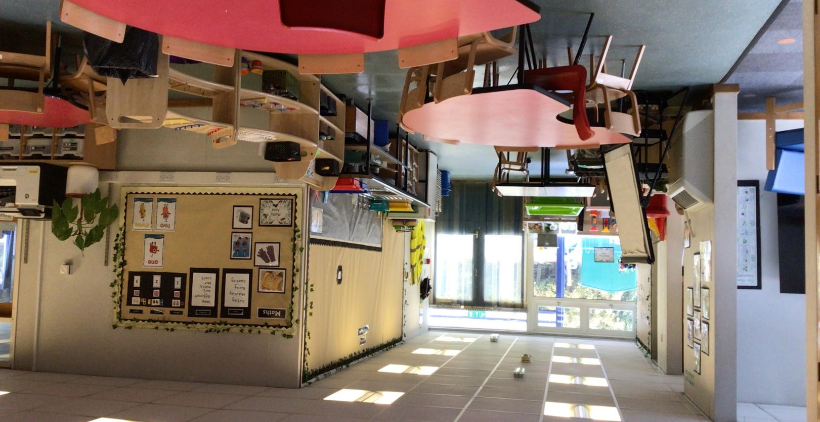

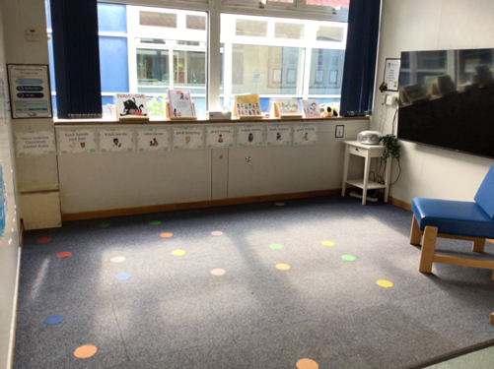
Our carpet area and water play area.
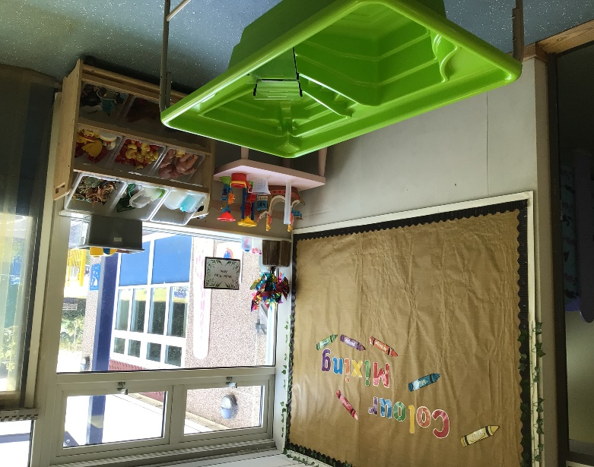

Our outdoor classroom
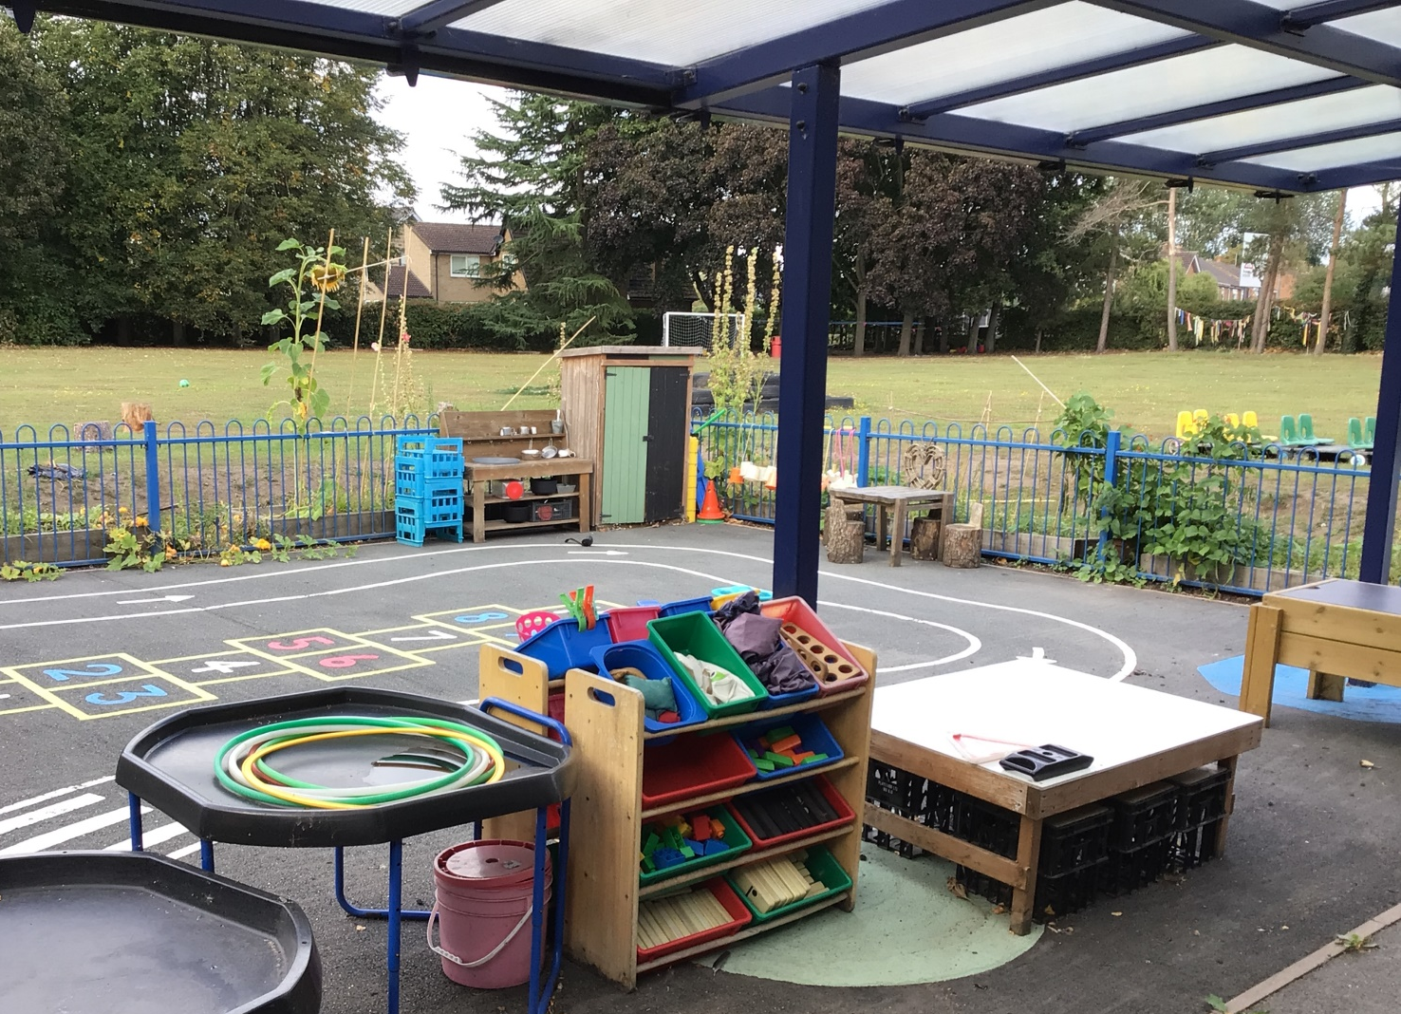
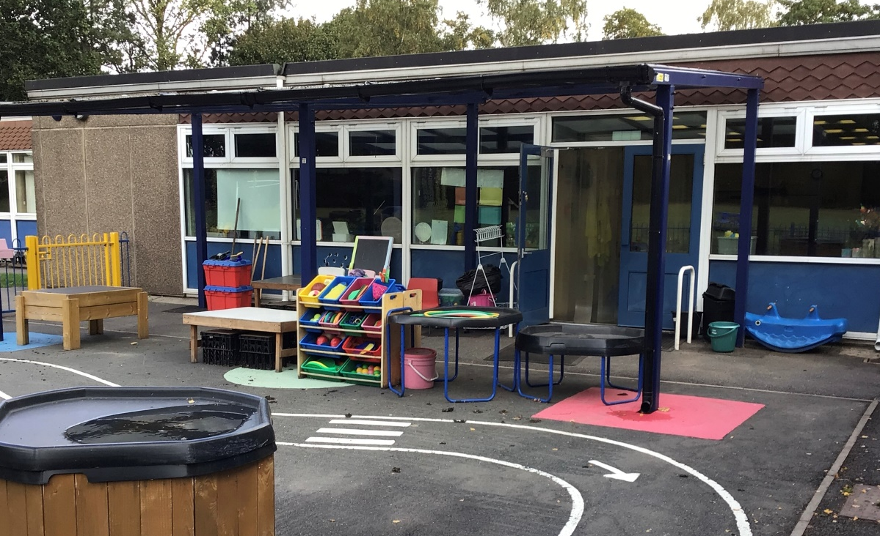

This is the hall.
We have lunch in the hall.
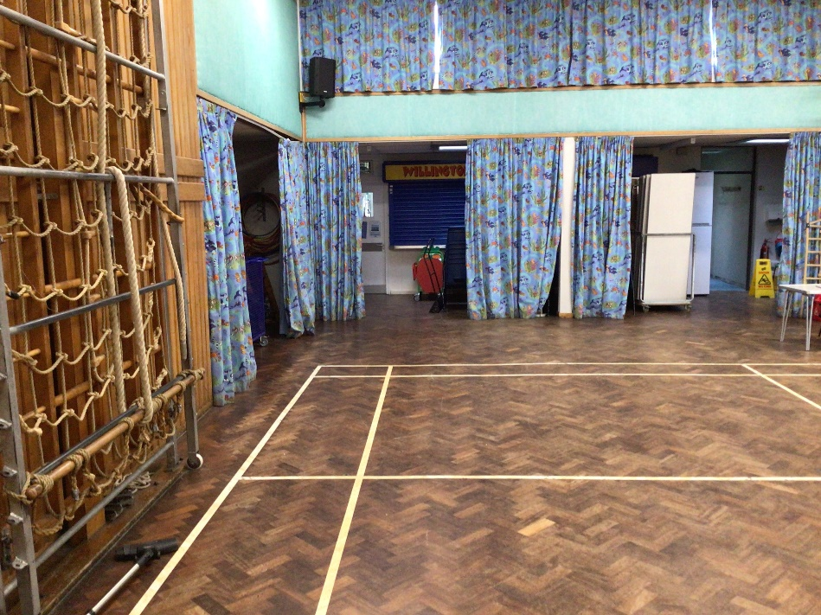
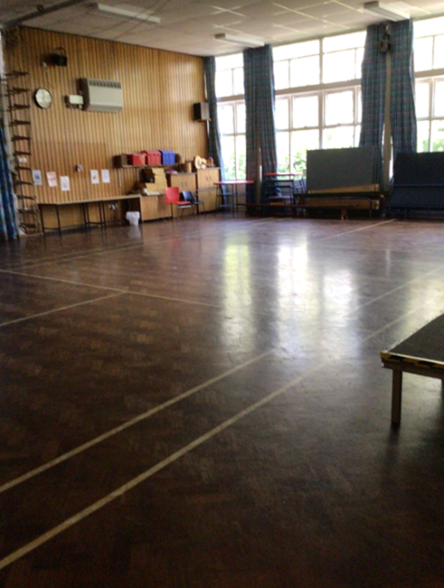

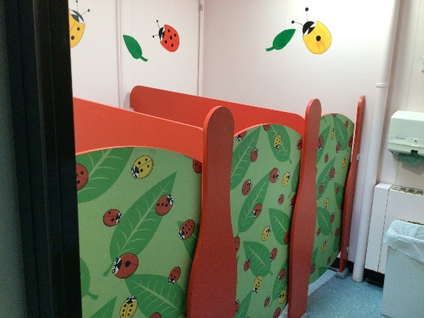
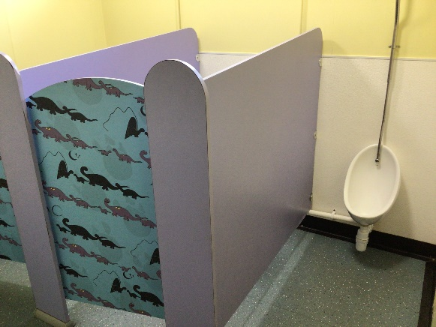
These are the toilets for the boys and girls.
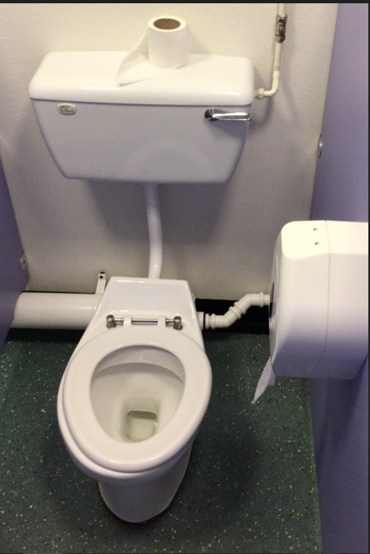

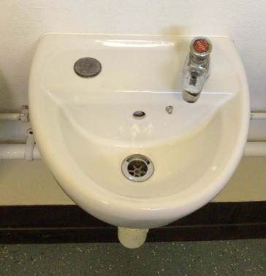
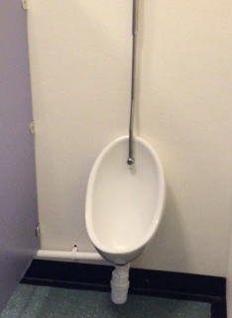

This is the library.
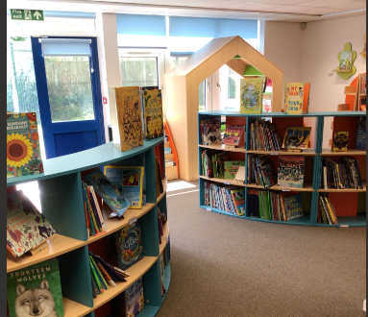

…………………………………………
We are all looking forward to seeing you at school soon!
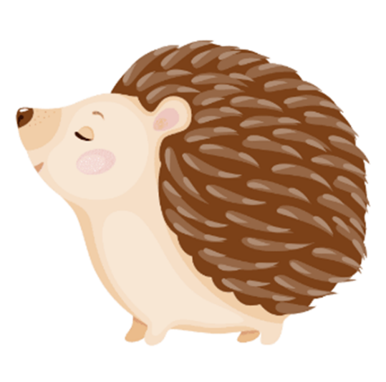
Remember to look after your hedgehogs over the
summer holiday.

